## **MOBILE PHONE DATASET ANALYSIS REPORT**

**Submitted By**

**Hima.C**

**1.INTRODUCTION**

This report analysis a dataset of mobile phones from a variety of brands. The goal of this analysis is to explore the key specifications of each phone, including battery capacity, screen size, RAM, camera quality, and price. Insights derived from this data can inform consumer preferences and guide manufacturers and marketers in feature prioritization.

The mobile phone market is highly competitive and diverse, with a vast array of brands and models catering to various consumer segments. From budget-friendly options to high-end flagship devices, mobile phones are differentiated based on numerous specifications, including battery life, camera quality, display size, processing power, and storage capacity. These features, combined with brand reputation and pricing strategies, influence consumer buying decisions and define market trends.

This report aims to analysis a dataset of 1,347 mobile phones from prominent brands such as Apple, Samsung, Xiaomi, and Realme, among others. The dataset includes 22 attributes, covering specifications like battery capacity, screen size, RAM, and price. By examining these features, we can identify which attributes most strongly influence pricing, determine feature trends across different price ranges, and uncover each brand’s unique market positioning.

## **2.DATASET OVERVIEW**

**Rows:** 1347 and **Columns:** 22

* **Name**: Full name of the phone, combining brand and mode.
* **Brand**: Manufacturer of the phone.
* **Model**: Specific model identifier.
* **Battery Capacity (mAh)**: Battery size in milliampere-hours, impacting phone usage duration.
* **Screen Size (inches)**: Physical screen size, measured diagonally.
* **Touchscreen**: Whether the phone has a touchscreen.
* **Resolution X** and **Resolution Y**: Horizontal and vertical screen resolution.
* **Processor**: Relative indicator of processing power.
* **RAM (MB)**: Memory in megabytes, affecting multitasking.
* **Internal Storage (GB)**: Built-in storage capacity for files and apps.
* **Rear Camera (MP)** and **Front Camera (MP)**: Camera quality in megapixels.
* **Operating System**: The phone's OS, typically Android or iOS.
* **Wi-Fi**, **Bluetooth**, **GPS**: Connectivity options available on the phone.
* **Number of SIMs**: Number of SIM cards supported.
* **3G** and **4G/LTE**: Network support for 3G and 4G.
* **Price**: Retail price of the phone.
* **Price Segment**: Price categorization.

**3.DATA PREPARATION AND CLEANING**

The dataset had no missing values or duplicates, ensuring a clean starting point for analysis. However, an inconsistency was found in the Internal Storage (GB) column, where some values were recorded as 0 GB, which does not reflect realistic storage capacities for mobile phones.

To address this:

Internal Storage Adjustment: All instances of values less than 1 GB in the Internal Storage (GB) column were replaced with 1 GB, representing a realistic minimum storage capacity. This adjustment maintains consistency in the dataset and allows for more accurate analysis of storage capacity across different phone models.

These adjustments ensured that the dataset was well-prepared for further analysis, with each feature accurately representing real-world values.

**4. EXPLORATORY DATA ANALYSIS (EDA)**

**Brand Analysis**

The dataset includes mobile phone models from a range of well-known brands, with some showing stronger representation.

* High-Performance Brands: Brands such as Apple, Samsung, and OnePlus dominate the high-end market. These brands typically offer models with larger screens, high battery capacities, advanced camera setups, and extensive storage options.
* Mid-Range and Affordable Brands: Xiaomi, Realme, and Vivo are prominent in the mid-range and budget segments, catering to price-sensitive customers with cost-effective models that still provide satisfactory performance for everyday use.
* There are 76 brands of mobile on this data.
* Count of some brands is here:

|  |  |
| --- | --- |
| **Brand** | **Count** |
| Intex | 117 |
| Samsung | 71 |
| Lava | 59 |
| Panasonic | 55 |
| … | … |
| Onida | 1 |
| Aqua | 1 |
| Jio | 1 |
| Razer | 1 |
| Philips | 1 |

**Price Overview**

* Range: Prices in the dataset range from ₹494 to ₹174,990.
* Average Price: Approximately ₹11,465, indicating a skewed distribution with many affordable models and fewer high-end models.
* Price Categories:

Budget (<₹30,000): Comprises the majority, with phones offering basic features.

Mid-Range (₹30,000- ₹75,000): Typically includes models with balanced specifications, suitable for most users.

Premium (>₹75,000): High-performance models targeting tech-savvy users needing advanced functionality.

* **Lyf Water 7** provides the best budget option at **Rs 494** making it ideal for cost-conscious buyers.
* For premium performance, the **Samsung Galaxy Z** Flip tops the list at a price of **Rs** **174990.**
* Price category count:

|  |  |
| --- | --- |
| **Price category** | **Total count** |
| Budget | 1274 |
| Mid-Range | 76 |
| Premium | 9 |

**Technical Specifications Overview**

**Battery Capacity**

* Range: 1010 mAh to 6000 mAh, with a median around 3000 mAh.
* Highest Battery Capacity: The top models with the highest battery capacity (6000 mAh) are:
* Samsung Galaxy M30s
* Asus ROG Phone 2
* Tecno Spark Power
* Other High-capacity models:

* Xiaomi Mi Max 2: 5300 mAh
* Lenovo P2: 5100 mAh

* Lowest Battery Capacity: some models with lower capacities include:
* Nokia Asha 501: 1200 mAh
* Lava A52: 1200 mAh
* Samsung Galaxy Pocket: 1200 mAh
* Samsung Z4: 1050 mAh
* Nokia Asha 502: 1010 mAh

**Screen Size**

* Range: Screen sizes span from 2.4 inches to 7.3 inches, with an average of around 5.3 inches.
* Popular Sizes: Models between 5.5 and 6.5 inches are common, reflecting market trends for larger displays favoured for multimedia use.
* Largest screen size:

* Samsung Galaxy Fold 7.30(inches)
* Asus ZenPad C 7.0 (Z170MG) 7.00(inches)
* Samsung Galaxy S20 Ultra 6.90(inches)
* Samsung Galaxy Note 10+ 6.80(inches)
* Samsung Galaxy A70s 6.70(inches)
* Smallest screen size:
* BlackBerry 9720 2.80(inches)
* Samsung Galaxy Y Pro Duos 2.60(inches)
* Nokia 8110 4G 2.45(inches)
* BlackBerry Curve 9220 2.44(inches)
* Jio Phone 2.40(inches)

**RAM**

* Range: From 64 MB to 12 GB, with common values in the 2-4 GB range.
* Insight: Devices with 4 GB or more RAM generally occupy the mid-to-high price range, catering to users requiring better multitasking capabilities.
* Highest RAM:
* OnePlus 7T Pro McLaren Edition 12000 MB
* Samsung Galaxy S20 Ultra 12000 MB
* Samsung Galaxy Note 10+ 12000 MB
* Samsung Galaxy Fold 12000 MB
* Oppo R17 Pro 8000 MB
* Lowest RAM:
* Lava Flair P1i 256 MB
* Lava A32 256 MB
* iBall Andi4 B20 256 MB
* Nokia Asha 501 64 MB
* Nokia Asha 502 64 MB

**Connectivity**

* **Network Support**:
  + **3G and 4G/LTE**: Widespread, with almost all models supporting at least 3G and the majority also supporting 4G/LTE.
  + **Insight**: Even in the budget range, basic 4G connectivity is standard, reflecting current telecom infrastructure and consumer demand for faster data speeds.

|  |  |
| --- | --- |
| **3G Network** | **Total count** |
| Yes | 1214 |
| No | 145 |

|  |  |
| --- | --- |
| **4G Network** | **Total count** |
| Yes | 1012 |
| No | 347 |

* **Other Connectivity Options**:
  + **Wi-Fi and Bluetooth**: Universally available, with some variations in Bluetooth version.

|  |  |
| --- | --- |
| **Wi-Fi** | **Total count** |
| Yes | 1351 |
| No | 8 |

|  |  |
| --- | --- |
| **Bluetooth** | **Total count** |
| Yes | 1344 |
| No | 15 |

**Operating System**

* **Android**: The dominant operating system, covering a wide range from budget to premium models.
* **iOS**: Exclusively on Apple models, generally occupying the high-end segment.

|  |  |
| --- | --- |
| **Operating system** | **Total count** |
| Android | 1299 |
| Windows | 19 |
| iOS 17 | 17 |
| Cyanogen | 10 |
| BlackBerry | 10 |
| Tizen | 3 |
| Sailfish | 1 |

**Touchscreen**:

* Indicates whether the phone has a touchscreen.
* **Values**: "Yes" or "No"
* **Relevance**: Standard in modern smartphones, but this field may vary in older or specialty devices.

|  |  |
| --- | --- |
| **Touchscreen** | **Total count** |
| Yes | 1342 |
| No | 17 |

**5.VISUALIZATION**

**Category Vs Count**

## **Touchscreen**

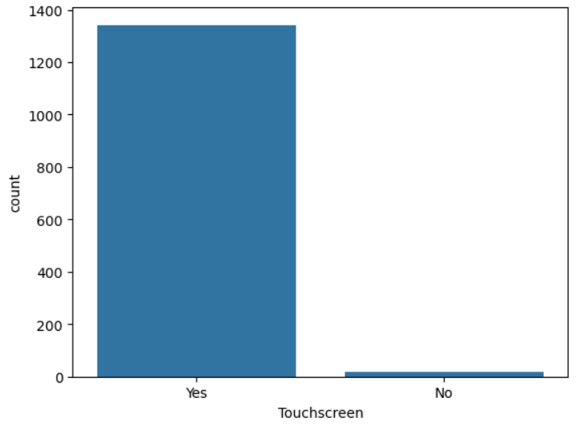

* Touchscreen Count: The majority of devices in the dataset have a touchscreen, as indicated by a much higher count in the "Yes" category.
* Low Non-Touchscreen Count: Very few devices lack a touchscreen, as shown by the shorter "No" bar.
* Imbalance in Data: The plot reveals an imbalance, with touchscreen devices vastly outnumbering non-touchscreen ones

## **Operating system**

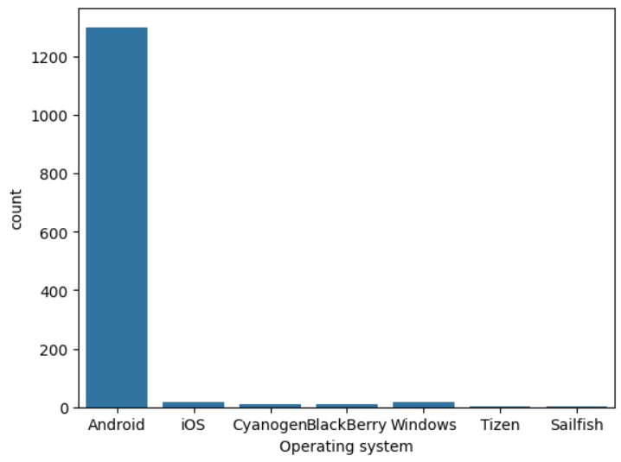

* Android Count: The majority of devices in the dataset run on the Android operating system, as indicated by a much higher count in the "Android" category.
* Low Count for Other Operating Systems: Very few devices use other operating systems like iOS, Windows, BlackBerry, and others, as shown by the shorter bars.
* Imbalance in Data: The plot reveals an imbalance, with Android devices vastly outnumbering those with other operating systems.

## **Wi-Fi**

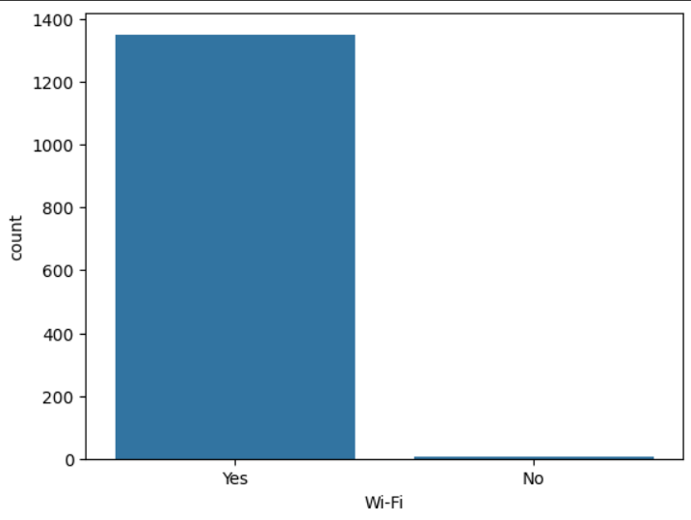

* High Count for Wi-Fi Enabled Devices: The majority of devices in the dataset have Wi-Fi capability, as indicated by a much higher count in the "Yes" category.
* Low Count for Non-Wi-Fi Devices: Very few devices lack Wi-Fi functionality, as shown by the shorter "No" bar.
* Imbalance in Data: The plot reveals an imbalance, with Wi-Fi-enabled devices vastly outnumbering non-Wi-Fi devices.

## **Bluetooth**

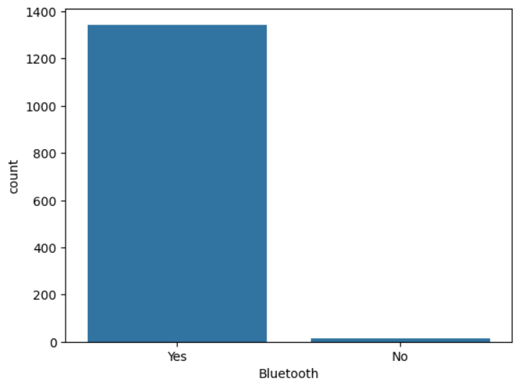

* High Count for Bluetooth Enabled Devices: The dataset shows a significantly higher count of devices with Bluetooth capability ("Yes"), indicating that most devices support Bluetooth connectivity.
* Low Count for Non-Bluetooth Devices: Very few devices lack Bluetooth functionality ("No"), suggesting that non-Bluetooth models are rare.
* Data Imbalance: The plot reveals a substantial imbalance, with Bluetooth-enabled devices vastly outnumbering non-Bluetooth devices.

## **GPS**

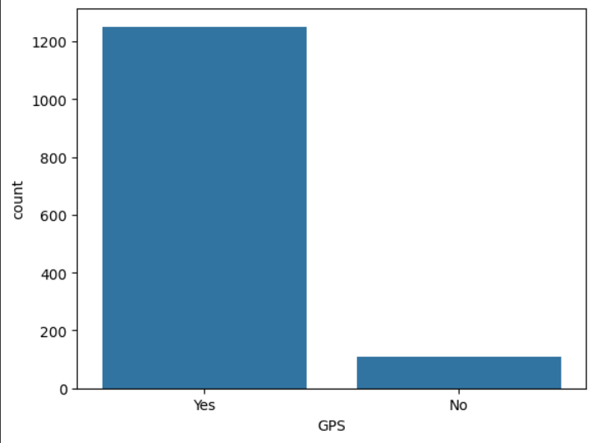

* High Count for GPS Enabled Devices: The dataset shows a significantly higher count of devices with GPS capability ("Yes"), indicating that most devices support GPS functionality.
* Low Count for Non-GPS Devices: Very few devices lack GPS functionality ("No"), suggesting that non-GPS models are rare.
* Data Imbalance: The plot reveals a substantial imbalance, with GPS-enabled devices vastly outnumbering non-GPS devices.

## **Number of SIMs**

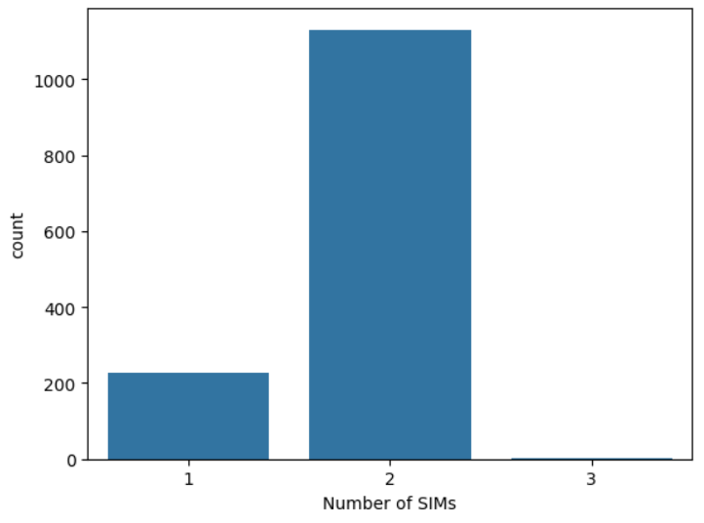

* High Count for Dual-SIM Devices: The dataset shows a significantly higher count of devices with dual-SIM capability ("Yes"), indicating that most devices support multiple SIM cards.
* Low Count for Single-SIM Devices: Very few devices lack 3 SIM functionality ("No"), suggesting that 3 SIM models are rare.
* Data Imbalance: The plot reveals a substantial imbalance, with dual-SIM devices vastly outnumbering 3 SIM devices.

## **3G**

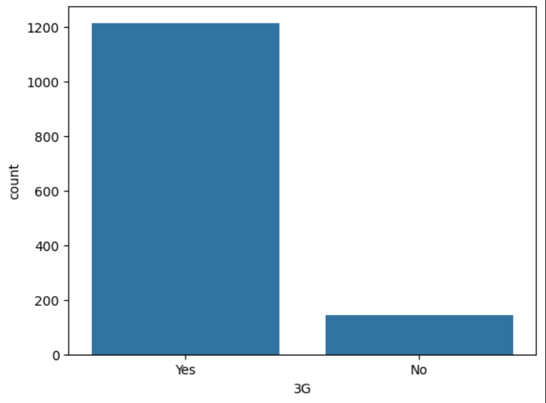

* High Count for 3G Enabled Devices: The dataset shows a significantly higher count of devices with 3G capability ("Yes"), indicating that most devices support 3G connectivity.
* Low Count for Non-3G Devices: Very few devices lack 3G functionality ("No"), suggesting that non-3G models are rare.
* Data Imbalance: The plot reveals a substantial imbalance, with 3G-enabled devices vastly outnumbering non-3G devices.

## **4G**

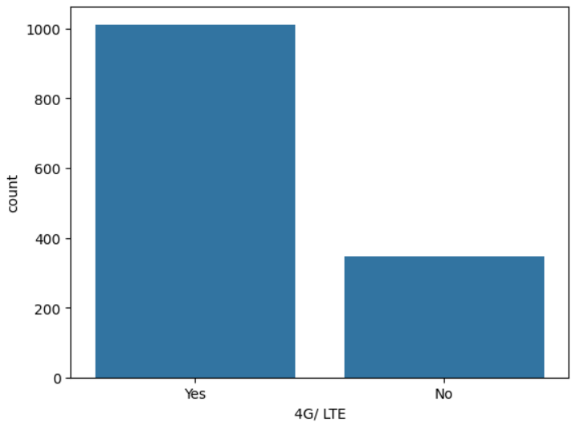

High Count for 4G Enabled Devices: The dataset shows a significantly higher count of devices with 4G capability ("Yes"), indicating that most devices support 4G connectivity.

Low Count for Non-4G Devices: Very few devices lack 4G functionality ("No"), suggesting that non-4G models are rare.

Data Imbalance: The plot reveals a substantial imbalance, with 4G-enabled devices vastly outnumbering non-4G devices.

**Price segment**

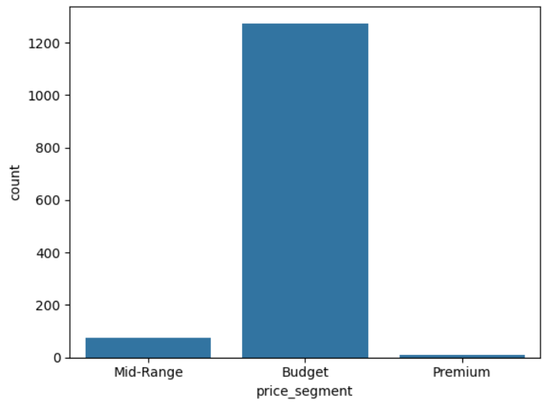

* High Count for Affordable Devices: The dataset indicates a significantly higher count of devices in the lower price segment, suggesting that most devices are priced affordably.
* Low Count for Premium Devices: Very few devices fall into the high-price segment, indicating that premium models are relatively rare in this dataset.
* Data Imbalance: The plot reveals a substantial imbalance, with affordable devices vastly outnumbering premium devices.

**Heatmap**

The heatmap presented the correlation matrix of the variables within the dataset. Each cell in the heatmap represents the correlation coefficient between pairs of variables, with values ranging from -1 to 1. A coefficient close to 1 indicates a strong positive correlation, while a value near -1 signifies a strong negative correlation. Values around 0 suggest little to no correlation between the variables.

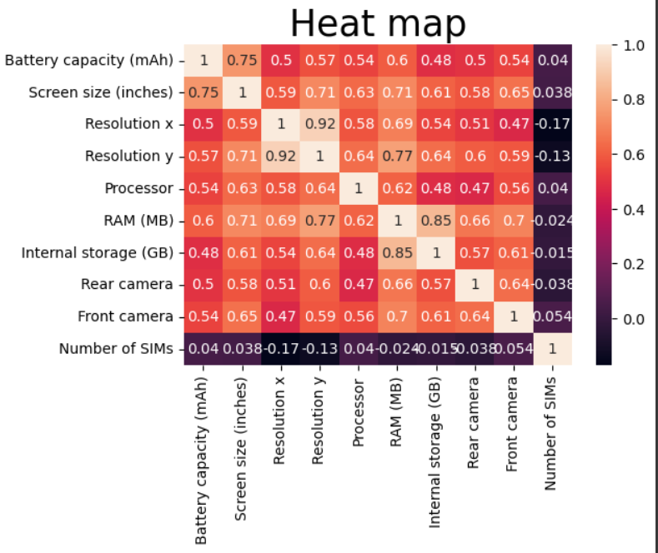

**Bar Plot Analysis of Average Price by Brand:**

The bar plot presented the average price of products across different brands within the dataset. The x-axis represents the brands, while the y-axis indicates their corresponding average prices.

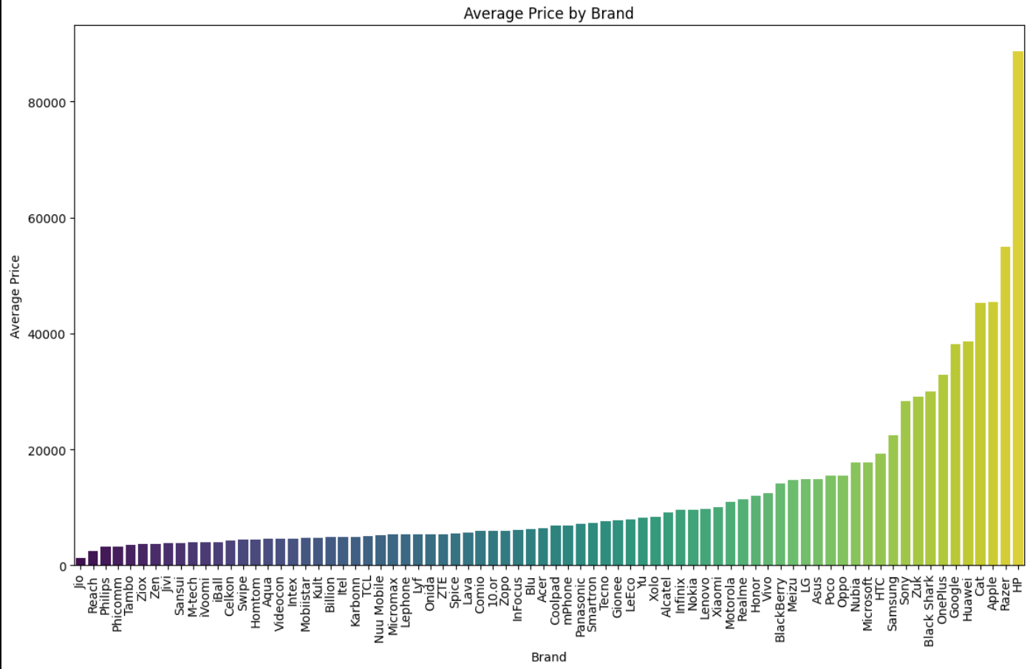

**Bar Plot Analysis of Average RAM by Operating System**

The bar plot displayed the average RAM (in MB) associated with different operating systems as indicated in the dataset. The x-axis categorizes the operating systems, while the y-axis quantifies their corresponding average RAM utilization.

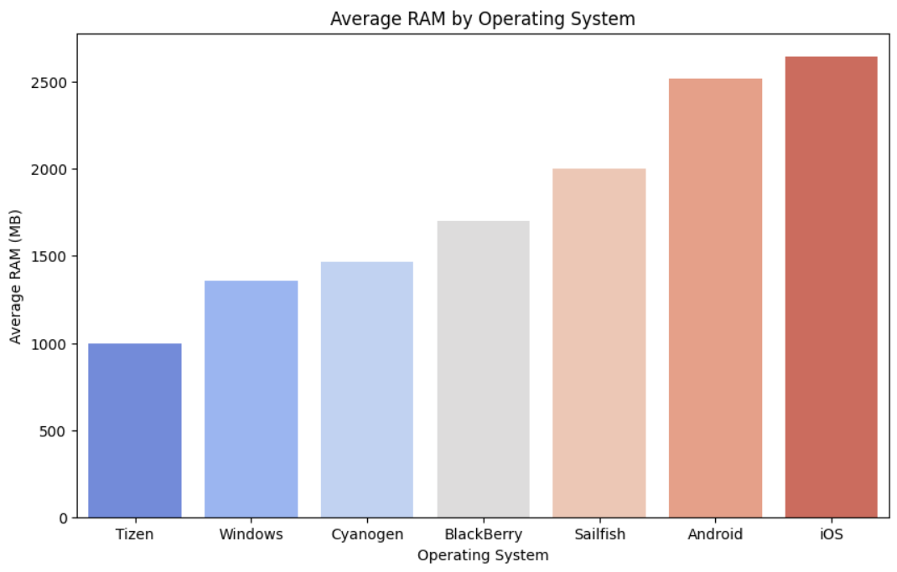

**Bar Plot Analysis of Average Rear Camera Megapixels by Brand:**

The bar plot illustrated the average rear camera resolution (in megapixels) across various smartphone brands within the dataset. The x-axis lists the brands, while the y-axis quantifies their average rear camera specifications.

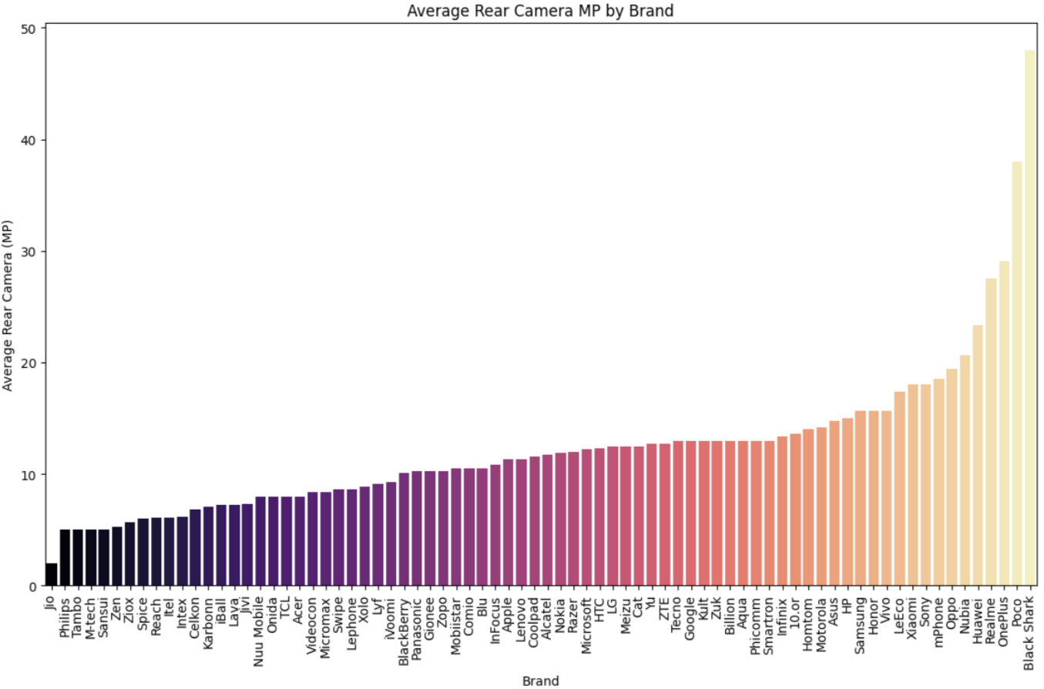

**Pie Chart Analysis of Price Segment Distribution**:

The pie chart illustrated the distribution of various price segments within the dataset. Each slice of the pie indicates the proportion of each price segment relative to the total number of entries. **Key Insights:**

* The **Premium** segment represents **1%** of the total.
* The **Budget** segment accounts for **6%** of the total.
* The **Mid-range** segment constitutes **94%** of the total.

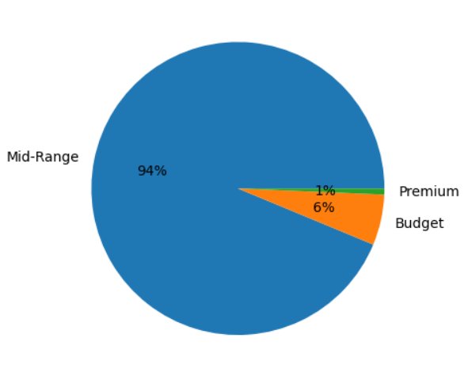

**6.CONCLUSION**

**Price Segmentation:**

* **Budget Phones:** Brands like Vivo, Xiaomi, and Realme offer competitive options for users seeking affordability, typically with balanced specifications suitable for everyday use.
* **Mid-Range Phones:** Models in the ₹30,000 to ₹75,000 range from brands like Samsung and OnePlus provide a mix of performance and affordability, making them suitable for most users.
* **Premium Phones:** High-end models from Apple, Samsung, and OnePlus, priced above ₹75,000, focus on performance and features like high-resolution cameras, powerful processors, and large displays.

**Feature Preferences:**

* **Battery Life and Screen Size:** Higher battery capacities and larger screens are more common in premium phones, appealing to users who need devices for multimedia and extended use.
* **Storage and RAM:** While budget models may have limited RAM and storage, premium models commonly feature larger capacities to support advanced functionalities.
* **Camera Quality:** High-resolution cameras are primarily found in mid-to-high-end models, reflecting the importance of photography features for today’s users.

**Brand Positioning:**

* **Apple and Samsung:** Maintains a premium positioning, targeting high-end consumers.
* **OnePlus:** Offer a range from mid to high-end, balancing premium features with more accessible pricing.
* **Xiaomi and Realme:** Lead in the affordable segment, providing quality specifications for budget-conscious users.

**Recommendations**

* **For Power Users:** High-end models from Apple, Samsung, and OnePlus are suitable for users needing top performance, larger storage, and high-resolution cameras.
* **For General Users:** Mid-range models offer balanced specifications for most daily tasks without a high price tag.

## **For Budget-Conscious Users:** Brands like Vivo a Xiaomi offer cost-effective options with sufficient performance for everyday use.